


FOR IMMEDIATE RELEASE
March 21, 2016

Contact: Stephanie Zajac, PHYCO_{2:} (202) 440-2995, Stephanie@NahigianStrategies.com;
Sarina Gleason, Media Communications: (517) 355-9742, cell (517) 256-5618, sarina.gleason@cabs.msu.edu
Katie Gervasi, IPF Communications, (517) 432-3629, kgervasi@ipf.msu.edu

PHYCO₂ and MSU Make Breakthrough in Clean Air Technology, Growing Pure Algae
24/7 and Without Sunlight

EAST LANSING, Mich. – PHYCO₂ -an emerging algae growth and carbon dioxide sequestration company- has made a technology breakthrough in Phase I of the multi-year trial with Michigan State University (MSU). The technology partnership set out to capture manmade carbon dioxide (a greenhouse gas emission (GHG)) and create renewable alternative energy feedstock. Phase I proved the technology can capture significant amounts of CO₂ for high-density algae cultivation with the PHYCO2 Patented algae photo bioreactor.
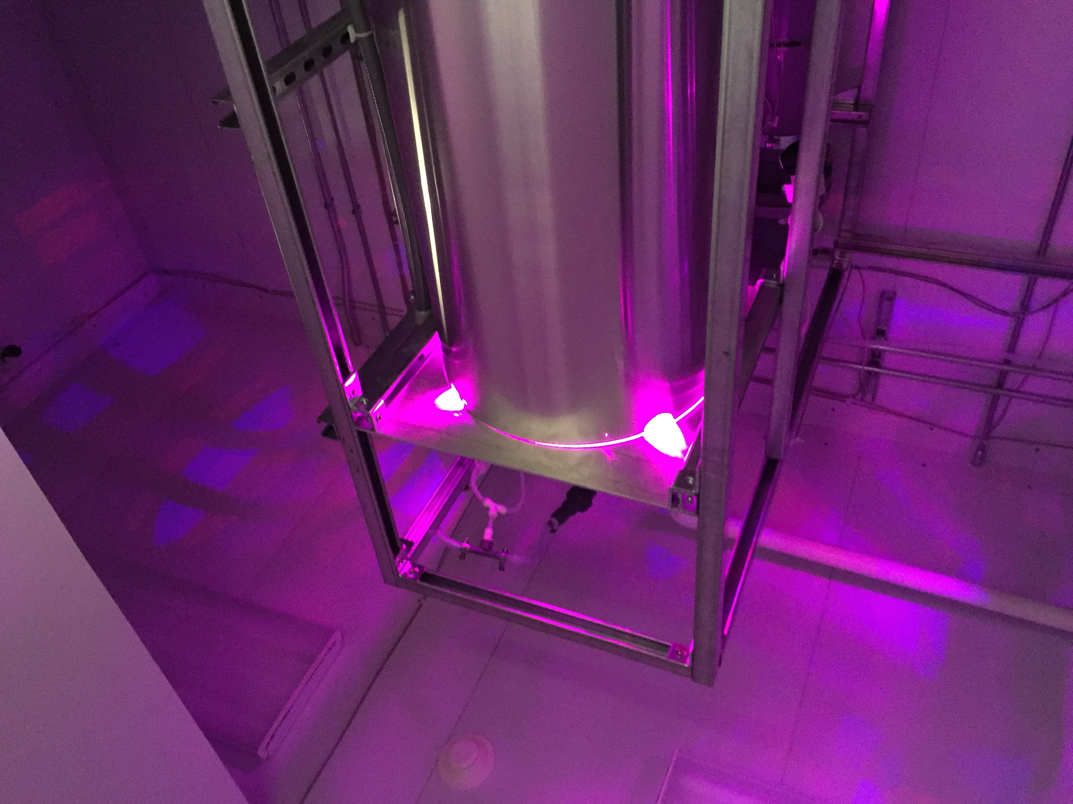
PHYCO₂’s patented technology allows uncontaminated microalgae to grow indoors 24 hours a day, without sunlight, in any geographic location, year round. It is the first photo bioreactor to optimize algae growth by managing all the growth parameters (light, CO2 and nutrients). Unlike previous open and closed systems, the PHYCO₂ photo bioreactor system eliminates possible contamination from outside sources. Discovering the specific amount of time that algae needs to be exposed to light, as well as the time needed to rest in order to properly cultivate, PHYCO₂ developed a system that is market sustainable and commercial.
PHYCO₂’s Photo Bio-reactor in operation at MSU

Working closely together, MSU and PHYCO₂ found breakthrough results that out perform current open-pond systems, as well as competing studies being done at other universities. Within the first round of testing, the two-month period showed an algae density of 1.7 g/L, a CO₂ absorption rate of 52 percent, and a productivity rate of 0.34 g/l solution/ day, higher than the algae and production rates found at recently reported studies.

Built in the T.B. Simon Power Plant, PHYCO₂’s photo bioreactor absorbs CO₂ emissions directly from the plant, creating pure algae strands that can be used for a multitude of products. Algae are used for an array of everyday products, from lipstick to ice cream, to gasoline and animal feed. The team is preparing for a second round of testing, in which the focus will be on doubling their algae density and reaching a productivity rate that is eight times the Phase I rate.

“With the strong industry-university collaboration, the integration of the patented PHYCO₂’s reactor and MSU selected algal strains could lead to a soon-commercially-available solution to sequester CO₂ and produce high-value chemicals. Co-locating the APB with the power plant allows the process to utilize waste heat from the power plant to dry and process the produced algae to further improve the energy balance”, said Dr. Susie Liu, an assistant professor in the Department of Biosystems and Agricultural Engineering at Michigan State University.

“Results from Phase I testing demonstrates that our technology can be applied to manufacturers worldwide to reduce emissions, and create pure microalgae to be used as an alternate energy source, as we strive to create a market sustainable solution to address our environment without negatively impacting businesses,” said PHYCO₂ CEO William Clary. “The next phases of testing will focus on how effective the photo bioreactor can be for power plants looking to reduce their carbon footprint, and how the technology can be implemented to absorb other airborne pollutants for further algae cultivation.”

The studies conducted at MSU with PHYCO₂’s photo bioreactor represents the future of cleaner emissions and the first CO₂ capture technology that truly is marketable, allowing MSU to continue to be at the forefront of cutting-edge research and development. The collaboration is a direct response to the White House and U.S. Environmental Protection Agency’s call documented in the Clean Power Plan, and the UN Climate Change Conference, recently held in Paris. To follow the progress and learn more about the MSU and PHYCO₂ partnership, you can visit www.phyco2.us.

About PHYCO₂:
Santa Maria, Ca.-based PHYCO₂ is a commercial algae growth and CO₂ sequestration company at the forefront of algae production research and technology development. The company’s revolutionary patented HILED Algae Photo-bioreactor (US Patent #8,476,067 B2 and Canada Patent #2717862) sequesters CO₂ while reclaiming water and producing algae without sunlight or risk of mass contamination at an accelerated rate. This breakthrough technology yields up to six times the amount of algae as “open” methods for use in high-demand markets such as defense and transportation fuels. For more information about PHYCO₂, visit http://phyco2.us.

About Michigan State University
Michigan State University has been working to advance the common good in uncommon ways for more than 150 years. One of the top research universities in the world, MSU focuses its vast resources on creating solutions to some of the world’s most pressing challenges, while providing life-changing opportunities to a diverse and inclusive academic community through more than 200 programs of study in 17 degree-granting colleges. www.msu.edu

About the T.B. Simon Power Plant
The T.B. Simon Power Plant is a co-generation plant that provides steam, heat and electricity for the university. Also known as “combined heat and power,” the plant utilizes steam to generate electricity. Boilers create steam that passes through a turbine generator. The electricity and the steam are then distributed across campus. The steam is mainly used to heat and cool buildings. The T.B. Simon Power Plant is an ideal environment for the partnership with PHYCO₂ to research technology that recycles carbon dioxide emissions to accelerate the growth of algae. http://ipf.msu.edu/green/energy/generating-power.html

# # #

