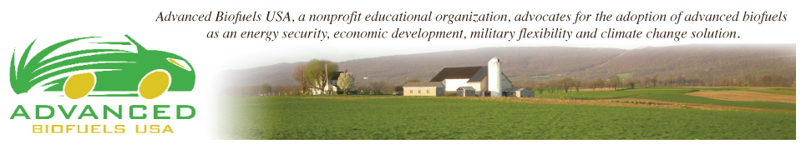

Watch What They Do--The Obama Administration and Climate Change:
What It Looks Like from a Transportation Perspective

As Attorney General John Mitchell said in 1969 at the beginning of the Nixon Administration,
"Watch what we do, not what we say.”

So, let's apply that formula to clearly understand the Obama Administration’s record on reducing climate change.

If you listen to President Obama's speeches, he says he is a leader.

However, over the past 6 years the actions of the Obama presidency tell a different story. Shale oil and gas fracking have boomed. He's even opening up the Arctic and Atlantic to oil drilling and has imposed no new restrictions on deep water drilling.

In the transportation sector, what does Obama "reducing climate change" look like?

Obama promised a million clean electric cars on the roads by 2015; but was only able to get 160,000 EVs (16% of his promise) on the roads out of a US vehicle fleet of 225 million.

Is Obama serious about providing a clear pathway to have vehicles meet the new 54.5 mpg CAFE standards?

To the contrary. It appears that he and his administration are doing all they can to prevent more efficient, lower GHG cars and trucks from traveling our roads. Negative actions by the Administration include:

- Disadvantaging production of more efficient, lower GHG emitting engines by restricting reasonably priced higher octane/higher ethanol fuels through new EPA Tier 3 Certification Fuel and R-Factor regulations,
- Removing Flex Fuel Vehicle production incentives through EPA Guidance Documents, and
- Reducing investment incentives for advanced biofuels by refusing to implement the Renewable Fuel Standard according to clear legislative intent.
What these actions add up to is a concerted effort by the Obama Administration to restrict American motor vehicle and renewable fuel innovation.

If this and future Administrations continue on this course, the last bastions of good jobs in American, the agriculture and automotive industries could go the way of the steel, microprocessor, and biochemical industries.

If this Administration is truly serious about producing cars and trucks that go the farthest using the least amount of life cycle carbon while retaining keystone American industries, they should immediately reverse the actions of the last six years.

How?

Start with these three actions.

- EPA CAFE and related Clean Air Act regulations on vehicle manufacturers should be rewritten to encourage fuel and drive train innovations to meet the 54.5 mpg goal at the lowest cost to consumers. The “R” factor should be set at 1.0 per Oak Ridge National Laboratory data (see http://advancedbiofuelsusa.info/high-octane-ethanol-blends-for-improved-vehicle-efficiency/; and FFV incentives should be immediately restored.
- Obama's Administration should enforce the Renewable Fuel Standard according to the laws that were passed by Congress in 2005 and 2007 to institute a transition to renewable transportation fuel use. The current approach that justifies the restriction on Advanced Biofuels because of “current market conditions” was intentionally excluded from the legislation.
- The Administration should expand and simplify the USDA renewable fuel delivery infrastructure program. The goal of a US program should be to have at least one blender pump per station to give customers a real choice of fuels.
For the next Administration and Congress, a larger issue should be confronted – the synchronizing of fuel combustion and fuel production policy for heat, power and transportation.

The Clean Air Acts of 1970 and 1977, while great pieces of legislation, were products of their time. An entire Title was devoted to motor vehicle control while fuel regulations (that is, regulation of the oil/gas industry) remained minimal even with important additions in the 1990 Act. We have learned much since then and now realize that fuels and engines must be treated as part of one system.

Again, if the goal of this country is to reduce energy use and GHG emissions, then laws such as the Clean Air Act should be based on the systems approach used by nature as well as scientists and engineers to produce meaningful innovations.

In the 1970s Congress followed Attorney General Mitchell’s advice and showed America that leadership could lead to a respect for laws and create an environment for innovation.

In the coming 2016 Presidential and Congressional elections we need to make the benefits of Renewable Energy and Climate Change reduction an issue at every opportunity.

Because simply, it is what the people in America and the world want.
We need to make it something that American candidates want as well.

